Guide to Online Registration
～Hong Kong Version～
2016
CATALOGUE
REVISION NOTES 2
STEP1 NEW USER REGISTRATION 3
1-1 REGISTRATION WITH EMAIL 3
1-2 A PASSWORD EMAIL SENT TO YOUR EMAIL 4
STEP2 APPLICATION PROCEDURE 5
STEP3 PAGE FOR APPLICATION 6
STEP4 CONFIRMATION PAGE 7
STEP5 COMPLETION OF THE APPLICATION 8
STEP6 PAYMENT OF APPLICATION FEE 9
6-1 ABOUT THE PAYMENT OF APPLICATION FEE 9
6-1-2 PAYMENT VIA BANK TRANSFER 12
6-1-3 DISCOUNT COUPON (PAID) 13
6-2 COMPLETION OF THE PAYMENT 14
6-3 HOW TO FILL AND UPLOAD THE APPLICATION DOCUMENTS 14
6-3-1 UPLOAD THE PHOTO (REQUIRED) 16
6-3-2 UPLOAD LETTER OF APPLICATION AND REASONS (REQUIRED) 17
6-3-3 UPLOAD YOUR TRANSCRIPT 18
6-3-4 FINISH THE UPLOAD 25
6-4 COMPLETION OF PAYMENT 26
CONFIRM THE APPLICATION CONTENT 27
LOGIN FOR THE SECOND TIME 29
1. PAGE FOR LOGIN FOR THE SECOND TIME ① 30
2. PAGE FOR LOGIN FOR THE SECOND TIME ② 31
HOW TO OPERATE IF THE PASSWORD IF FORGOTTEN 32

Revision Notes

Version | Date of revision | Revision Notes/Revision History
Ver.1.0 | September 12, 2015 | First Edition

STEP1 New User Registration

1-1 Registration with Email
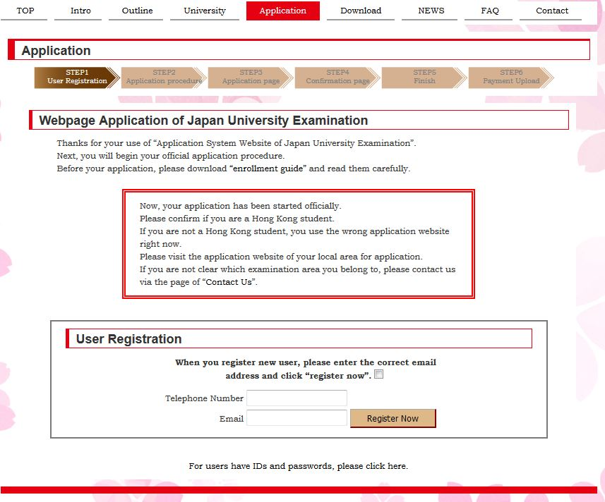
- When you register new user, please take the box and the enter the correct email address and click the button “register now”.
- 1）Please confirm the content in the red box

※There are certain differences between the application websites in different regions, therefore, the content shown in the red box is to remind students of confirming the corresponding website of the examination area you belong to.
If you are not clear which examination area you belong to, please contact us via the page of “Contact Us”.
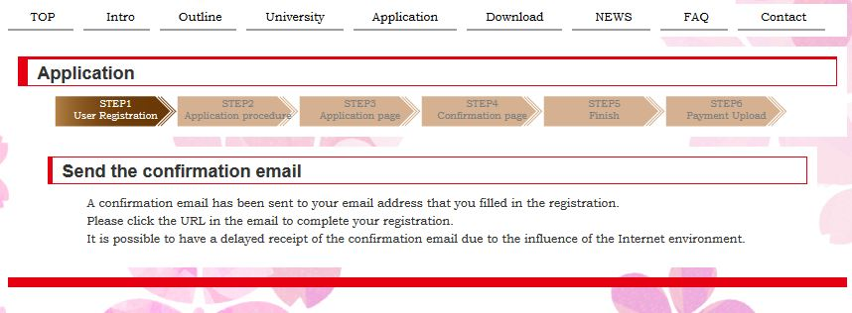
- This page shows a confirmation email has been sent to your email address that you filled in the registration.

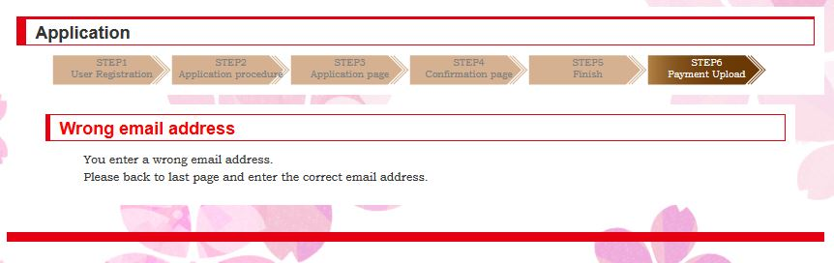
- If you enter a wrong email address, this page will appear.

1-2 A Password Email Sent to Your Email
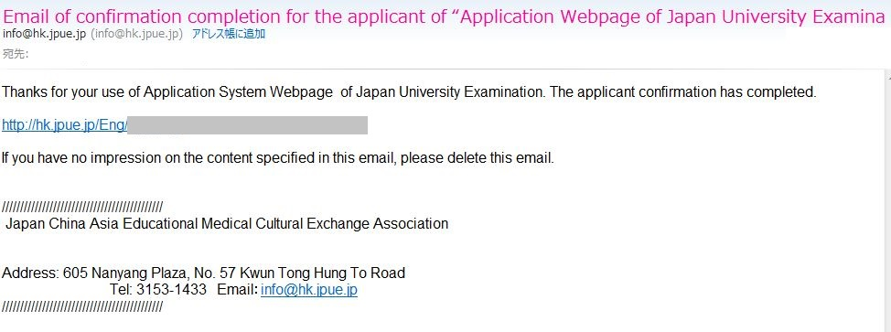
5）An email has sent to your email address that you filled in the registration.

Click the URL in the red box.
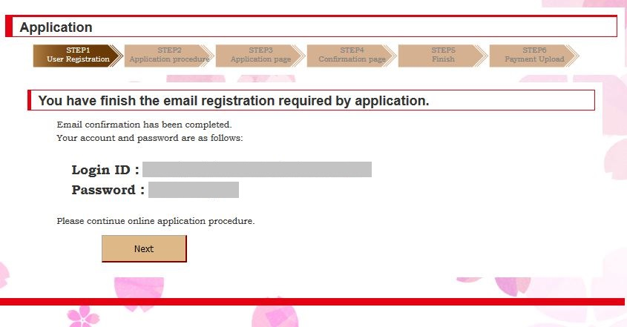
- After you click the URL in the email reminded in last step, you may see this page that need to enter account number and password, which will be remarked in the email sent to you.
- Continue your application steps, please click the button in the red box.

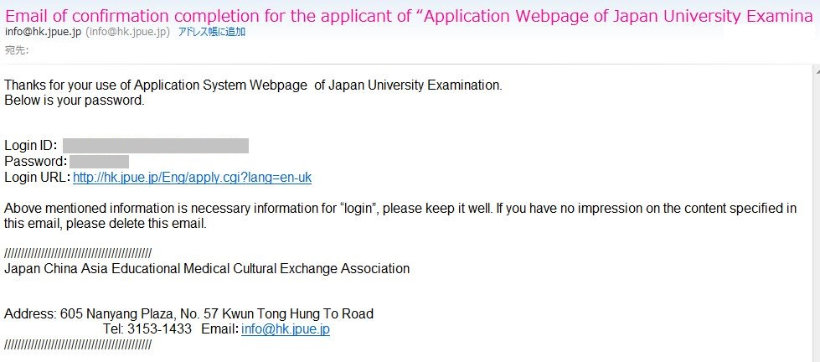
- The email has been sent in step 6) includes the login password.

STEP2 APPLICATION PROCEDURE
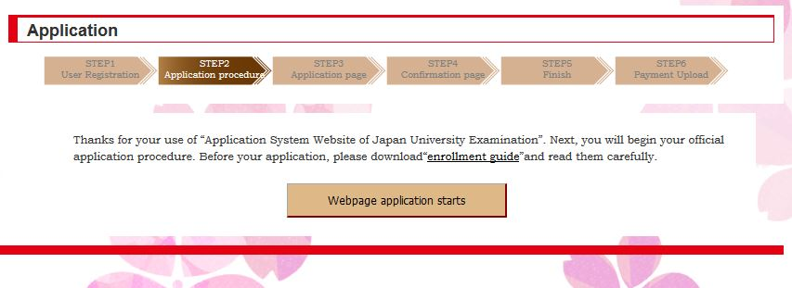
- This page will appear when you continue step 6). If you want to continue your application, please click the button in the red box.

STEP3 PAGE FOR APPLICATION
Please click the button in the blue box after you enter all items of “1）“～”14）”
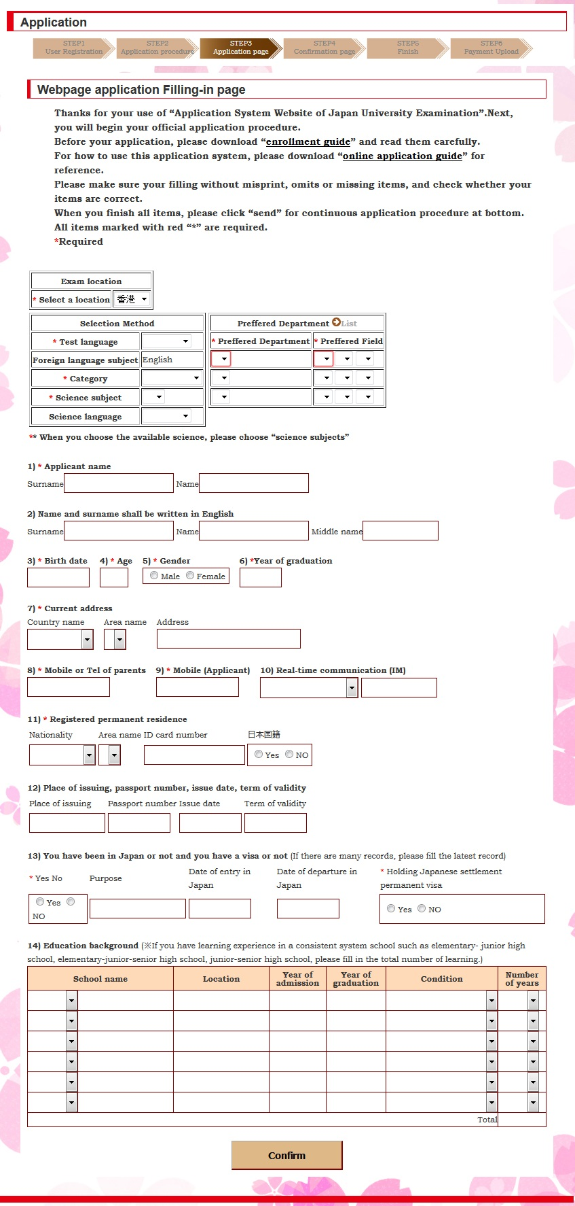
Choose the examination room, category and your preferred department.
Choose your preferred department (three at most) and your preferred field (nine at most).
All items marked with a red “*” is required on this page.

STEP4 Confirmation Page
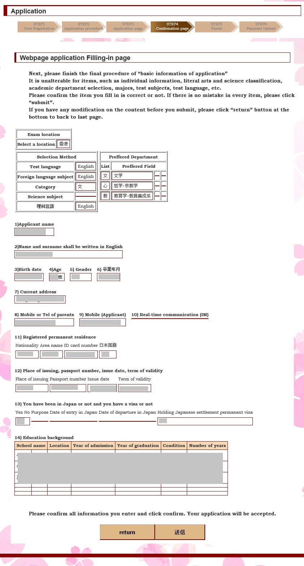
Please confirm the content you have filled on last page.
Return to last page for modification by clicking the button in the blue box.
Please click the button in the red box after confirming the content is correct.

STEP5 Completion of the Application
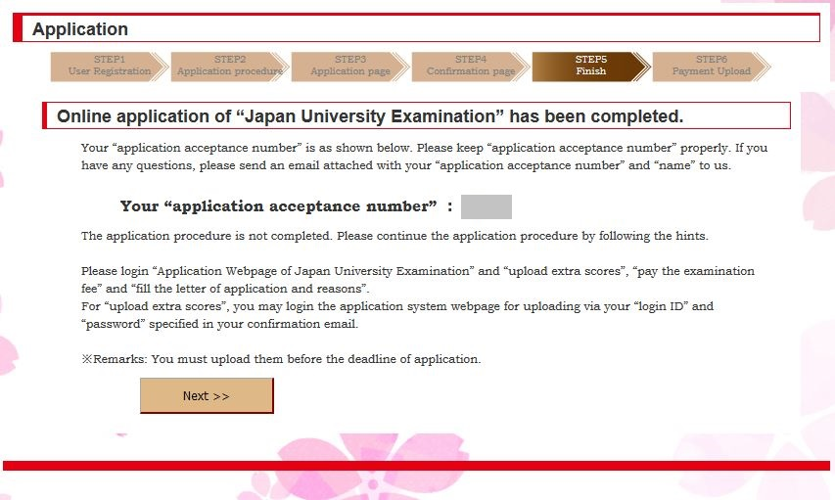
The page of registration acceptance. If you want to pay the application fee, please click the button in the red box.
An email will send to your email address that you filled in the registration when you see above mentioned page.
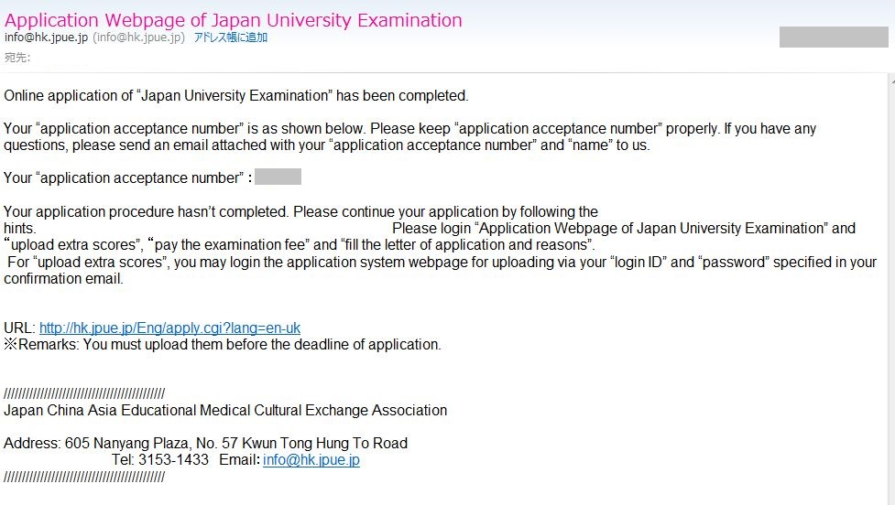

STEP6 Payment of Application Fee

6-1 About the Payment of Application Fee
About the payment method, three methods are as shown in the blue box. You can only use one way to pay the application fee. Once you finish with one method, other two are not available.
① After you click the button“Pay Now”, you may see the page below and then it will skip to the external link and you may pay with your credit card.
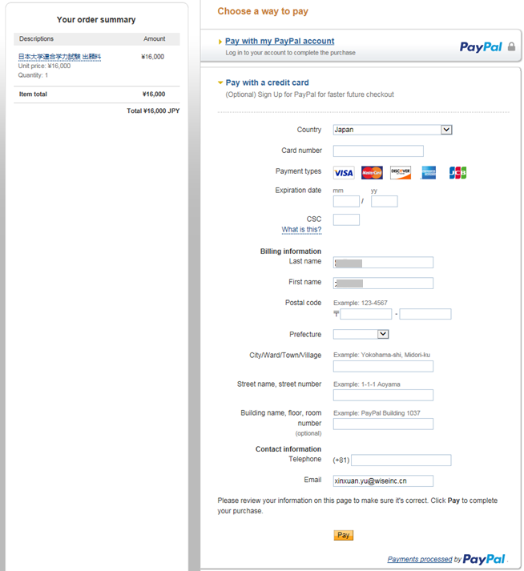
② Confirm the amount
④ Click “PAY” for payment
③ Fill the required information

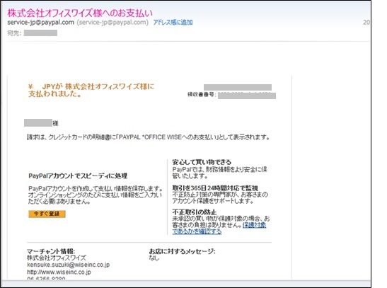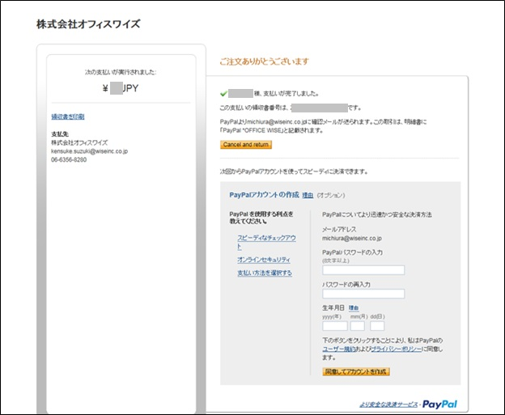
⑥ This page is the same as “⑤” and an email will be sent to your email address after your finish your payment with a credit card.
⑤ After completing the payment, you may see the button in the red box as shown in this picture and you may return the login website (The page when you complete the payment in the Guide 6-2)

6-1-2 Payment Via Bank Transfer
- Please choose your scanning swift of your bank transfer and click the button “upload”.

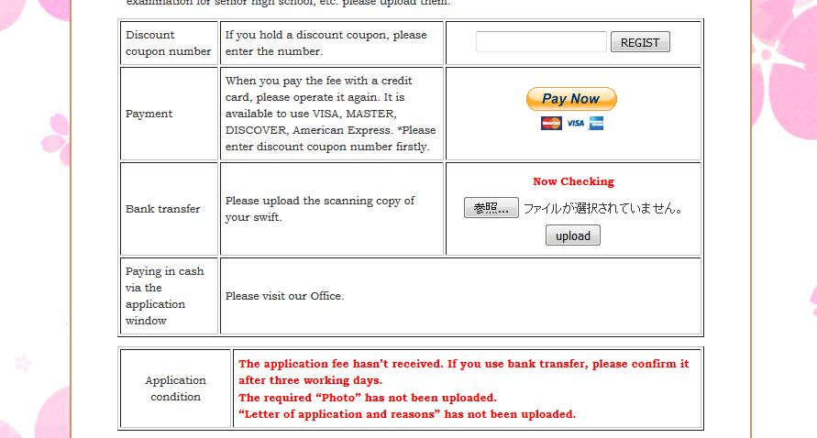
②After the upload is finished, you may see "now checking" and after we confirm your payment, you will return the application website (the page "Completion of Payment 6-2" in this guide)

6-1-3 Discount Coupon (Paid)
① If you hold a discount coupon, please enter the number and click “REGIST”。
After you finish your payment with the discount coupon, you’ll see the registration page (as the page “6-2 Completion of Your Payment” in this guide).

6-2 Completion of the Payment
13) After you finish your payment, please confirm the information about the account condition of the application fee in the blue box.

6-3 How to Fill and Upload the Application Documents
・The upload sequence is at will.
・When you leave the webpage at the halfway, you may return the midway status when you login again.
※ For details, please refer to “login in for the second time” page.
- Please read the text in the blue box carefully.
- Click「edit」or「upload」in the green box.

6-3-1 Upload the Photo (Required)
Please choose your photo file and click the button “upload”. After the upload is finished, the content in the blue box will turn into “done”.
※ The size of the photo shall be 3 inches (L) ×4 inches (H), resolution 300dpi and it is required the photo took within three months.

6-3-2 Upload Letter of Application and Reasons (Required)
① Please click the button in the blue box.
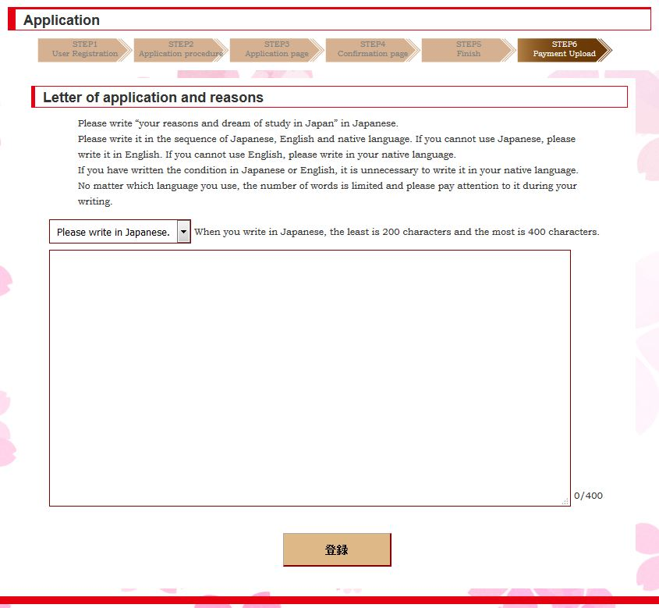
② Please choose your enter language in the drop-down list box.
※ Please note that the requirements on the number of characters differ from languages.
※ The blue box will show the number of characters you have entered.

③ Please click the button in the red box to save what you have entered.
④ After you finish your enter, you may see “Done” as shown in the red box.
If you have any modification in the letter of application and reasons, please click the button “edit” in the blue box.

6-3-3 Upload Your Transcript
Please click the upload button to upload the transcripts as shown in this guide Chapter“1”～“6”.

1. Transcript of EJU
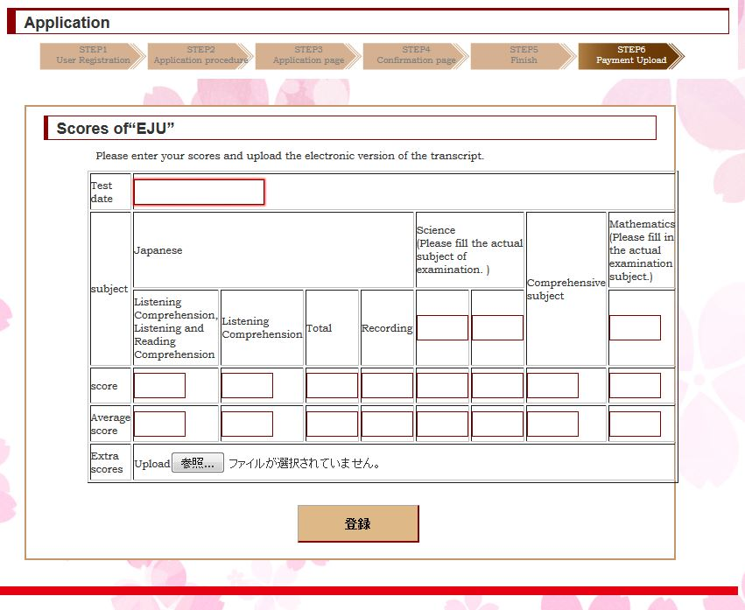
③ Please click the button in the red box after you check all contents carefully.
※It is not available to return for correction after login.
② Click the button in the blue box and then choose and upload your corresponding electronic edition of your transcript.

① Please fill in the blank in the green box.

2. How to Fill Japanese Language Proficiency Certificate
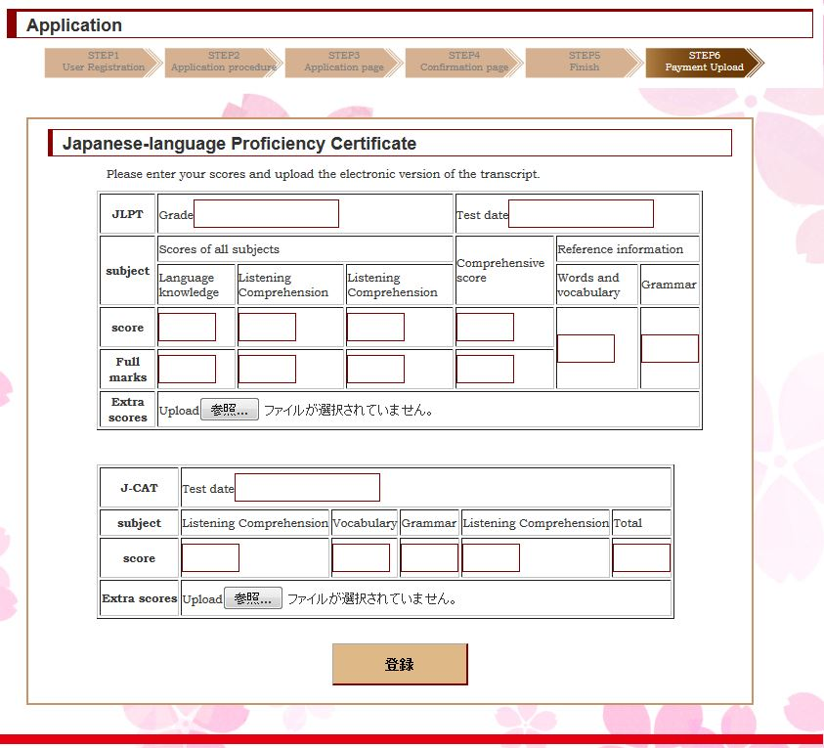
③ Please click the button in the red box after you check all contents carefully.

※ It is not available to return for correction after login.

① Please fill the corresponding content in the column of the examination category (as shown in the green box).
② Click the button in the blue box and then choose and upload your corresponding electronic edition of your transcript.

3. How to Fill English Ability Certificate
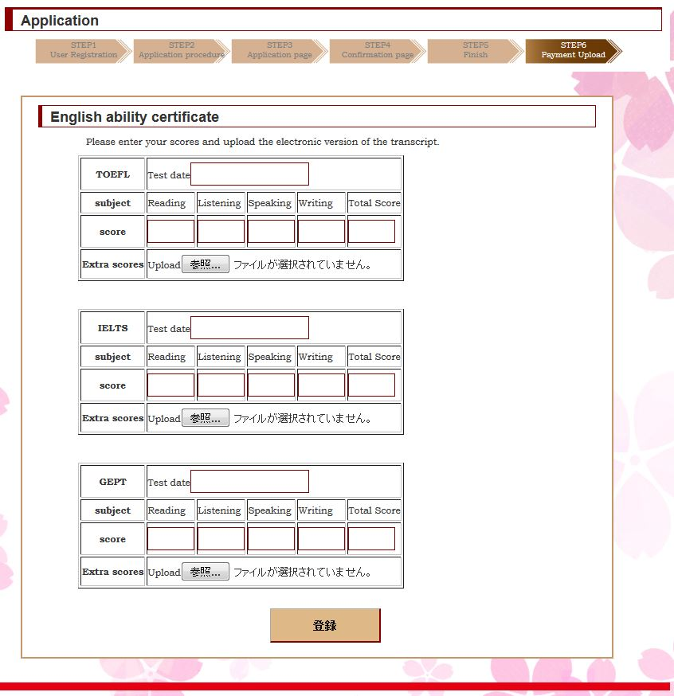
③ Please click the button in the red box after you check all contents carefully.

※ It is not available to return for correction after login.
②Click the button in the blue box and then choose and upload your corresponding electronic edition of your English ability certificate.
① Please fill the corresponding content in the column of English ability certificate (as shown in the green box).

4. How to Fill the Transcript of Your University Entrance Examination
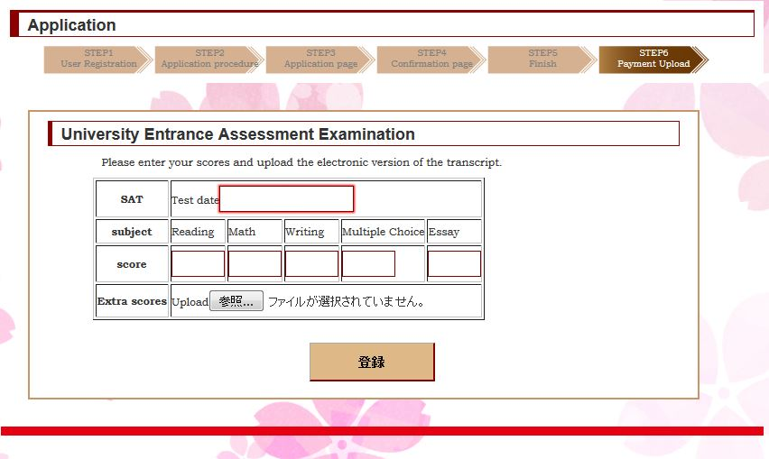
② Click the button in the blue box and then upload your corresponding electronic edition of your transcript.

① Please fill the corresponding content in the green box.

③ Please click the button in the red box after you check all contents carefully.
※It is not available to return for correction after login.

5. How to Fill Transcript of Domestic Examination 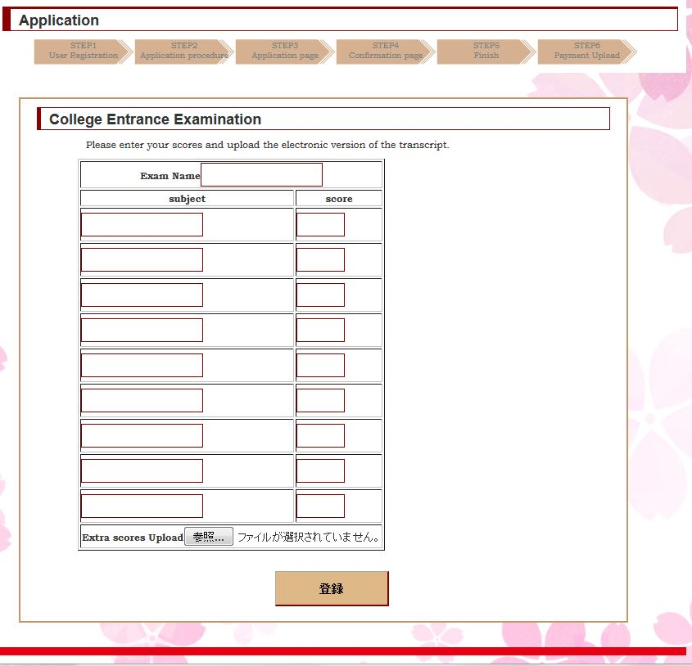
③ Please click the button in the red box after you check all contents carefully.

※It is not available to return for correction after login.

② Click the button in the blue box and then upload your corresponding electronic edition of your transcript.
① Please fill the corresponding content in the green box.

6. How to Fill the Transcript of Graduation Examination for Senior High School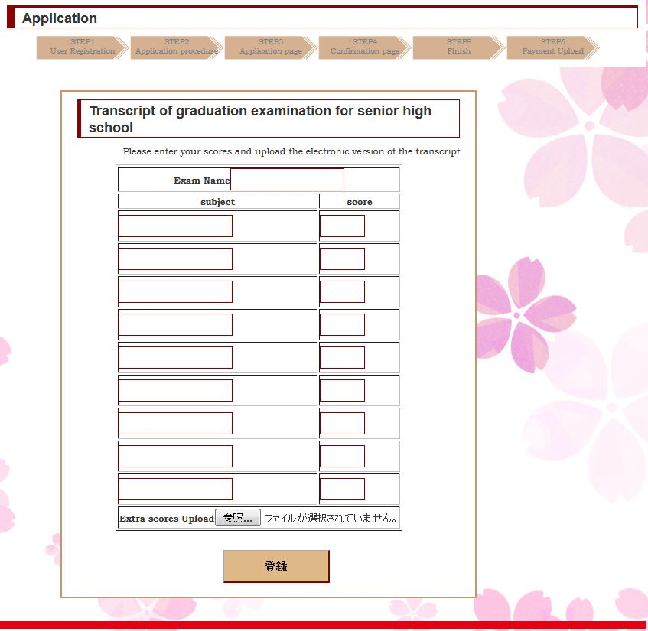
③ Please click the button in the red box after you check all contents carefully.
※It is not available to return for correction after login.

② Click the button in the blue box and then upload your corresponding electronic edition of your transcript.
① Please fill the corresponding content in the green box.

6-3-4 Finish the Upload
When the upload item is finished, you may see “done” in the red box. Please click “done” to review what you have entered.

6-4 Completion of Payment
If the payment of the application fee has been confirmed, the blue box will display.
- After you finished the required items “confirmation of the application fee” “upload the photo” and “letter of application and reasons”, you may see the button as shown in the red box. Click it and you will complete your application.

※ Once you click this button, all your application steps will be ended.
② After you complete the operation in Step ①, you will see the information as shown in the red box.

Confirm the Application Content
- Please click the button in the red box.
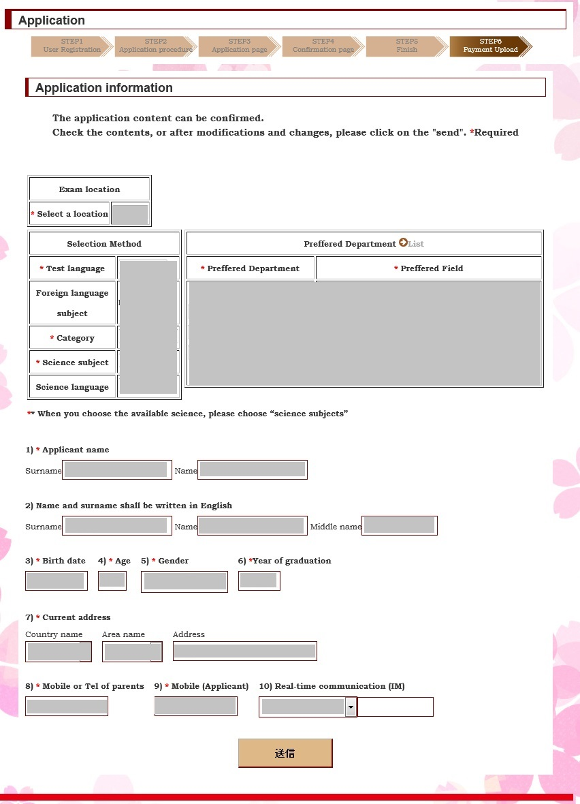
- Application information will be shown in the red box.

- Click the button in the blue box and you will return the page as shown in step “①”

- 青枠内のボタンをクリックすると「①」で表示していた画面が表示される。

Login for the second time
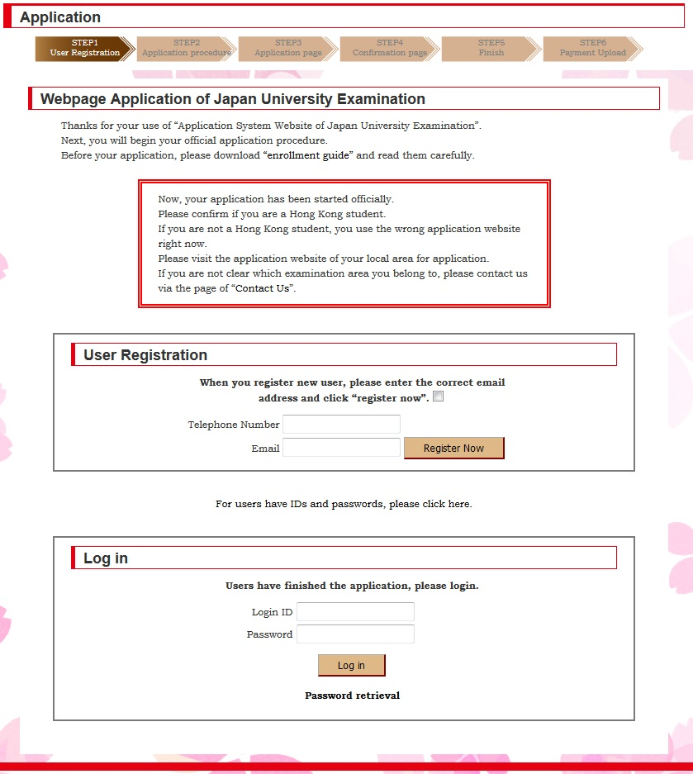
Click the text in the red box.
Please enter your user name and password provided in step1”1-2”

1. Page for Login for The Second Time ①
（No completion of application in STEP5）
Click the button in the red box to continue the application.

2. Page for Login for The Second Time ②
（The Completion Condition in Step5）
Complete the payment and the upload sequence is at will.

How to operate if the password if forgotten
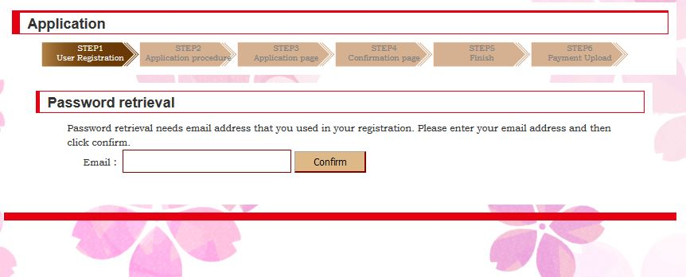
③ Please enter the mailing address in your registration in the red box
④ Click the button in the blue box

② Click the button in the blue box

① Click the button in the red box

- 。

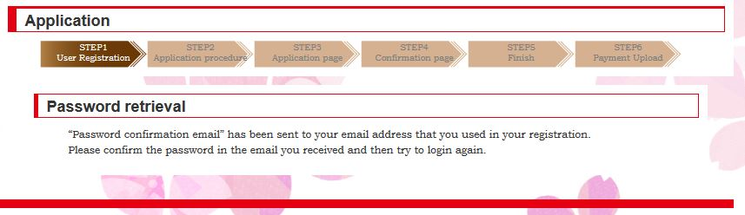
④ It shows a password retrieval email has been sent to your email address that you have entered.
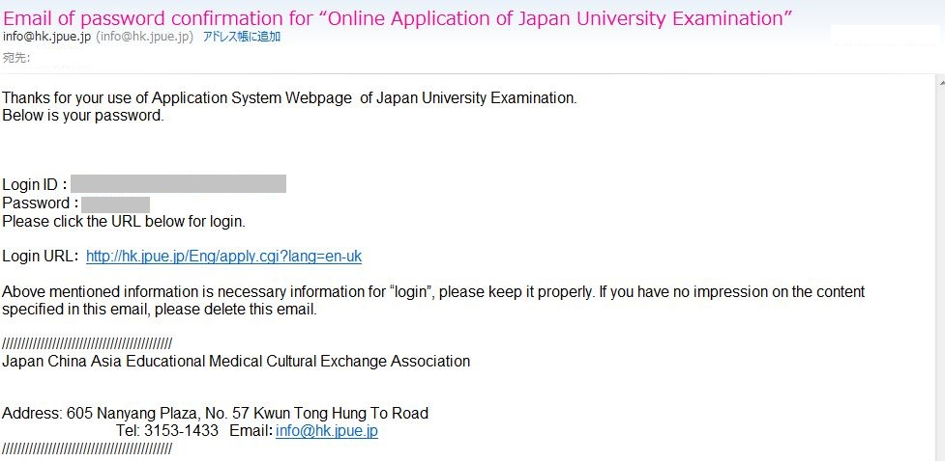
⑤ A password retrieval email has been sent to your email address that you have entered in Step “③”.

